**16-BIT ADDITION**

**EXP NO:5**

**AIM:** To write an assembly language program to implement 16-bit addition using 8086 processor.

**ALGORITHM:**

1. Select register bank 2.
2. Initialize carry counter to get result>16 bit.
3. Load LSB of first number in accumulator.
4. Add LSB of second number with LSB of first number.
5. Store LSB of result.
6. Load MSB of first number in accumulator.
7. Halt

**PROGRAM:**

LHLD 2500

XCHG

LHLD 2502

DAD D

SHLD 2504

HLT

**INPUT:**

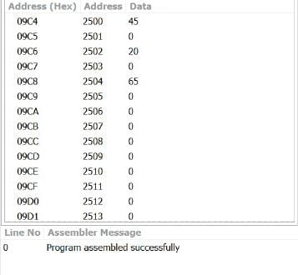

**OUTPUT:**

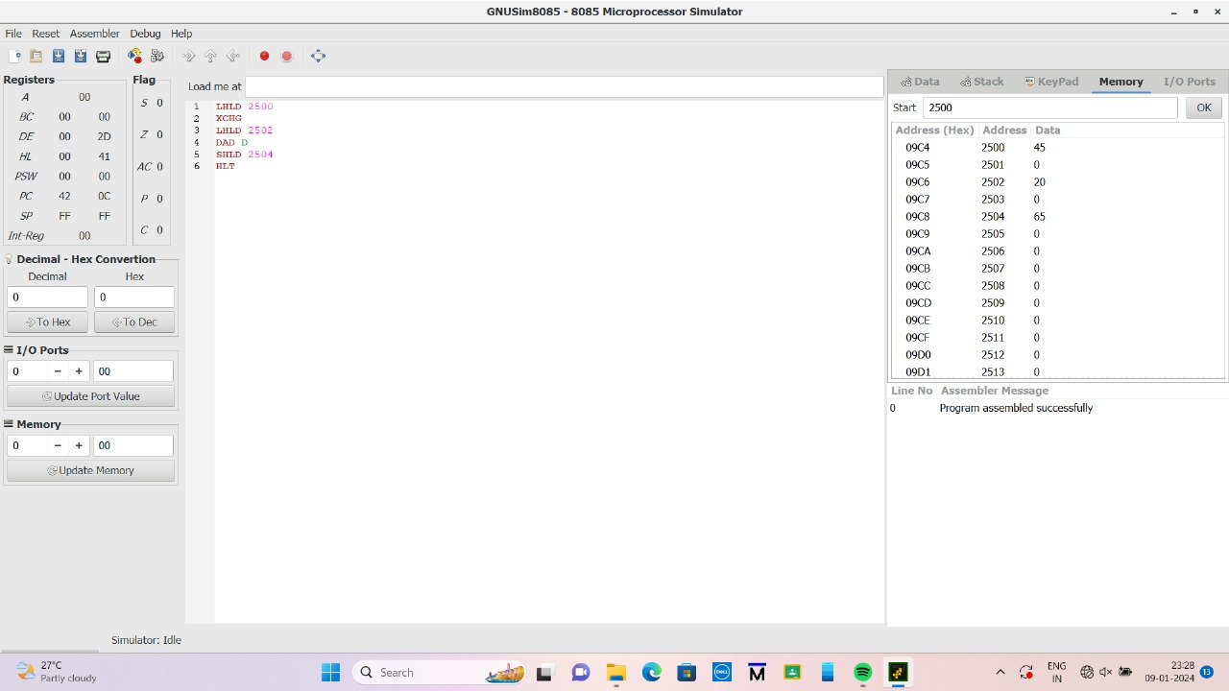

**RESULT:**

Thus the program was executed successfully using 8056 processor simulator.